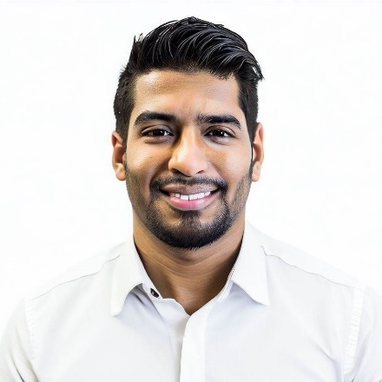

# Skills

* Search Engine Optimization (SEO)
* Search Engine Marketing (SEM)
* Social Media Marketing and Advertising
* Content Marketing
* Email Marketing
* Google Analytics and Marketing Analytics
* Marketing Automation
* A/B Testing and Conversion Rate Optimization
* Creative Content Creation
* Branding and Campaign Development

# Experience

Jan 2019 – Present

*Prime Digital Solutions, New Delhi*

**Digital Marketing Manager**

Orchestrated strategies for 30% traffic growth and 5:1 ROAS through Google Ads and social campaigns. Boosted organic search rankings by 40%.

Jul 2016 - Dec 2018

*Innovative Tech Solutions, Gurgaon*

**Digital Marketing Specialist**

Led 50% website traffic increase, managed social channels with 30% growth, and optimized email campaigns with 25% higher open rates.

# Profile

Experienced and result-driven Digital Marketer with expertise in SEO, SEM, social media, content, and email marketing. Skilled in data-driven optimizations, creative engagement, and building brand visibility. Committed to staying updated with the latest trends and technologies.

Sanjay Kumar

Digital Marketer

# Certifications

* Google Ads Certification
* HubSpot Inbound Marketing Certification
* Facebook Blueprint Citification

# Education

Bachelor of Business Administration (BBA) in Marketing

*Delhi University, New Delhi*

2016

# Contact



1, Main Street – New Delhi



+91 9876543210



sanjay.kumar@email.com



linkedin.com/sanjy.kumar